**ALIBI README**

The package alibi offers a lot of tolos of Explanaible AI. Some tools are the classic offers for differents packages as Partial Depedence or Permutation Importance, but there are others differents tools.

**In this sense, Alibi offers one of the most complete packages for explainable AI from classic tools to more complex ones.**

**MAIN MENU ALIBI – LIST OF TOOLS OFFERS**

<https://docs.seldon.io/projects/alibi/en/stable/overview/high_level.html>

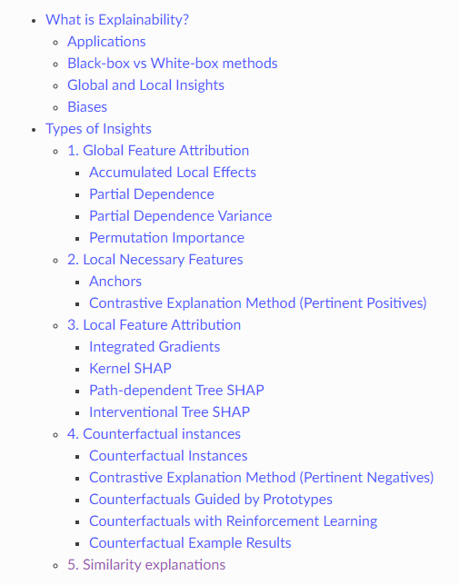

**MAIN MENU – USO DE LAS DIFFERENTES HERRAMIENTAS ALIBI**

<https://docs.seldon.io/projects/alibi/en/stable/overview/high_level.html#types-of-insights>

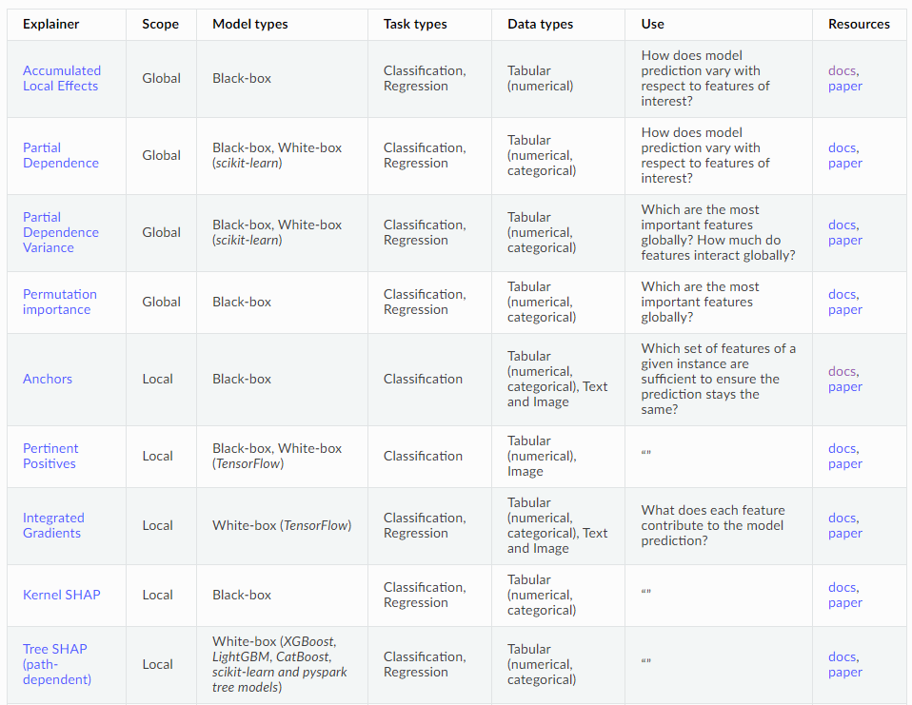

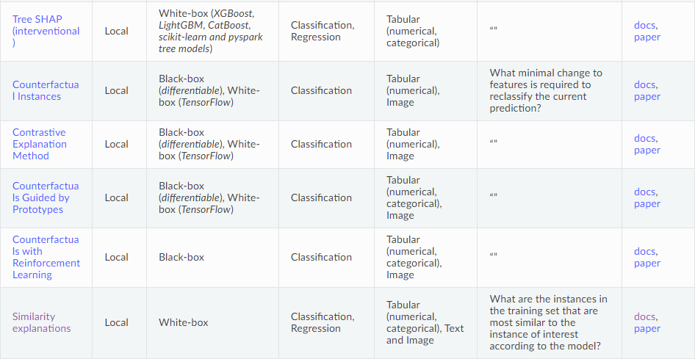

**LISTADO DE HERRAMIENTAS PARA SER UTILIZADAS EN MODELOS DE REGRESSION**

Listado de herramientas:

|  |  |
| --- | --- |
| **Explainer** | **Scope** |
| Accumulated Local Effects | Global |
| Partial Dependence | Global |
| Partial Dependence Variance | Global |
| Permutation Importance | Global |
| Integrated Gradients | Local |
| Kernel SHAP | Local |
| Tree SHAP (path-dependent) | Local |
| Tree SHAP (interventional) | Local |
| Similarity Explanations | Local |

**OBS: DATA IN ALIBI**

To use alibi it is neccesary the data need to be in format np.array()

X_train_numpy = X_train.to_numpy()

y_train_numpy = y_train.to_numpy()

X_test_numpy = X_test.to_numpy()

y_test_numpy = y_test.to_numpy()